**More Queries on Employee Database**

### Queries

**1.** **List all employees along with their project details (if assigned)**

Query : select e.ename, p.pname

from ASSIGNED_081 a, EMPLOYEE_081 e, PROJECT_081 p

where a.empno=e.empno and a.pno=p.pno;

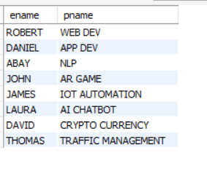

**2.** **Find all employees who received incentives, along with the total incentive amount**

Query : select e.ename , i.incentive_amount as total_incentive from EMPLOYEE_081 e, INCENTIVES_081 i where e.empno=i.empno;

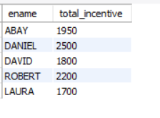

**3.List departments along with the number of employees in each department2019.**

Query : select d.dname, count(e.ename) as no_of_employee

from DEPT_081 d, EMPLOYEE_081 e

where d.dept_no=e.dept_no

group by e.dept_no;

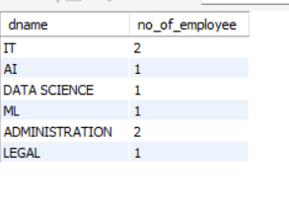

**4.** **Find employees who have not been assigned to any project**

Query : select e.empno

from EMPLOYEE_081 e

where e.empno not in(select a.empno from ASSIGNED_081 a);

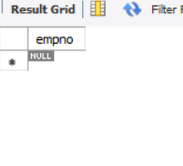

**5.List all employees along with their department names and location**

Query : select e.ename, d.dname, d.dloc

from EMPLOYEE_081 e, DEPT_081 d

where e.dept_no=d.dept_no;

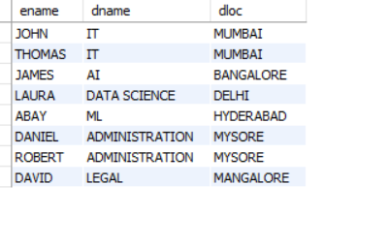

**6.Retrieve the details of employees who work under a specific manager (e.g., manager with empno = 5)**

Query : select ename, mgr_no, hiredate, sal, dept_no

from EMPLOYEE_081

where mgr_no=5;

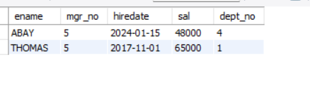

**7.List all projects that have employees assigned and the number of employees on each project:**

Query : select p.pname, count(a.empno) as no_of_employee

from ASSIGNED_081 a, PROJECT_081 p

where a.pno=p.pno

group by p.pname;

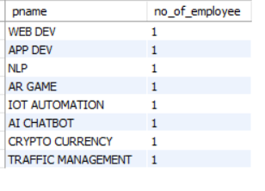

**8.** **Find employees with the same manager and list their department details**

Query : select e1.empno, e1.ename, d.dept_no, d.dname, d.dloc

from EMPLOYEE_081 e1

join EMPLOYEE_081 e2 on e1.mgr_no=e2.mgr_no and e1.empno<> e2.empno

join DEPT_081 d on e1.dept_no=d.dept_no;

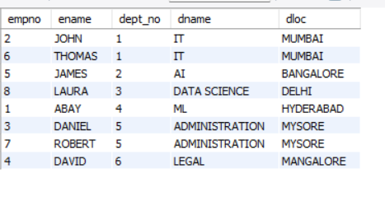

**9. Retrieve all employees who have the role of 'Developer' on any project:**

Query : select e.ename

from EMPLOYEE_081 e, ASSIGNED_081 a

where a.empno=e.empno and a.job_role like "%DEVELOPER";

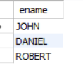

**10.** **Display the department-wise average salary of employees:**

Query : select avg(e.sal)

from EMPLOYEE_081 e, DEPT_081 d

where e.dept_no=d.dept_no

group by e.dept_no;

